Plasma Donor Application

TEAM ID : PNT2022TMID36558

# PROBLEM STATEMENT

During COVID 19 crisis the requirement for plasma increased drastically. The average donation rate for plasma has decreased from an already low 20% to a dismal 11%.

Considering the complex manufacturing process to fractionate plasma into the therapies patients rely on can take 7-12 months, any decline in donations is concerning.

Compounding the effects of ongoing decline checking the donor history, i.e., whether he

/she was infected previously and was recovered, and which donor is eligible to donate plasma was a challenging task.

Also, saving the healthy donor information, notifying the interested patients and matching the donors with the requestees proved to be a strenuous job.

## PROPOSED MODEL

The proposed method creates an application which aims to solve the aforementioned drawbacks. The system works with the registration of a donor by providing the required details which gets stored in the database.

## FEATURES

Whenever a new user posts a request, the donors with the matching blood group are notified about the request. Interested donors can then respond and donate their plasma.

## END USER

The user will be plasma requiring patients and the interested blood donors.

## SOFTWARE REQUIREMENTS

Python, Flask, Docker

## ARCHITECTURE

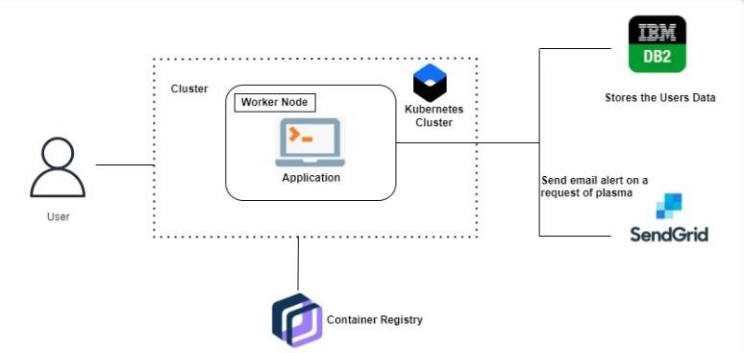

**PROJECT WORKFLOW**

* The user interacts with the application.
* Registers by giving the details as a donor.
* The database will have all the details and if a user posts a request, then the concerned blood group donors will get notified about it.

# USER INTERFACE

**Donor:**

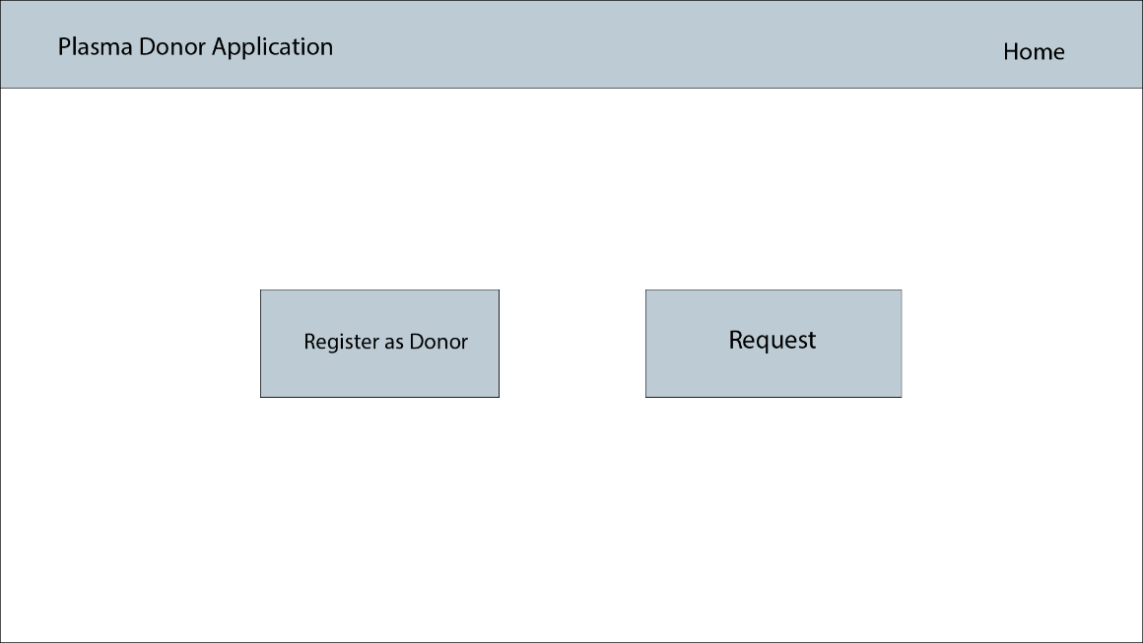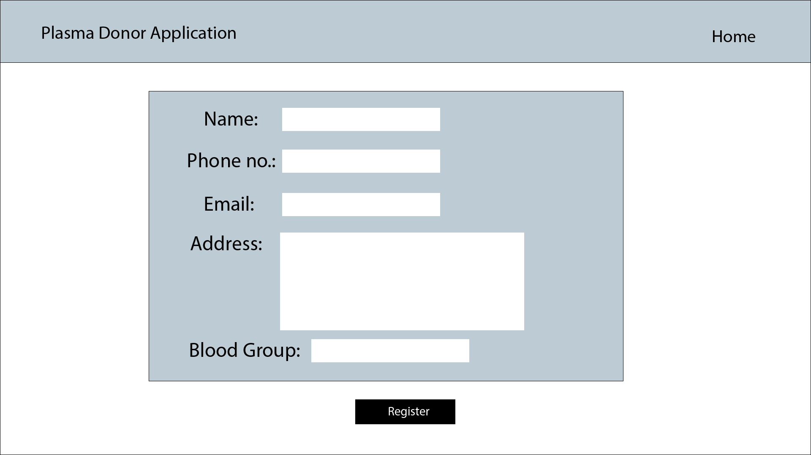

**Request:**

